How to Manage the Functions of your Text Box
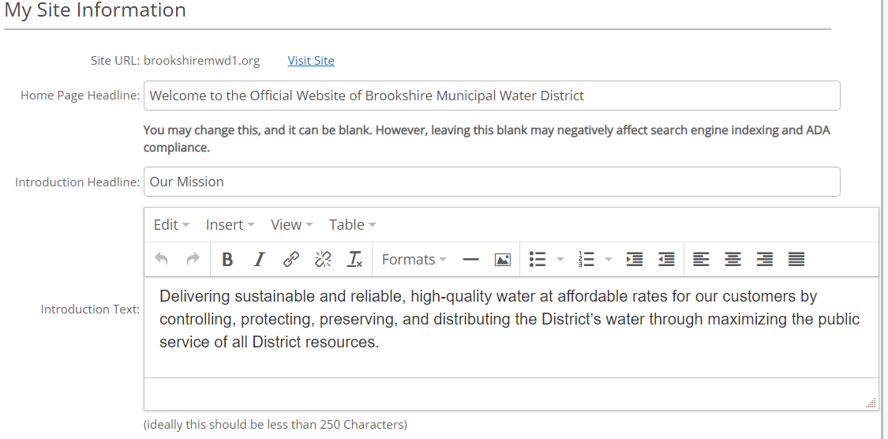
What is a text box in a website?
- Alternatively referred to as a text field, a text box is a section or object on a page that allows a user to enter text. The text box has features that allow you to edit, format and insert text, images, and links to your website.

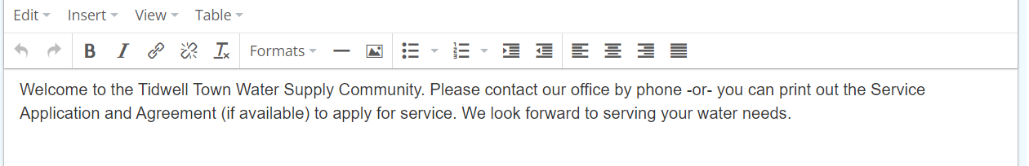
- Every text box has editing prompts across the top of the text box. (Edit, Insert, View, Table)
- Each one of these prompts has a drop-down arrow that allows you to activate actions that relate to that prompt.
- The EDIT prompt allows you to Cut (delete), Copy, Paste, Paste as Text, Select All, or Find & Replace any content text if the text is highlighted.
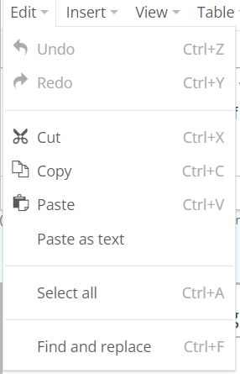
- The INSERT Prompt allows you to insert an Image, a Link, a Media Picture and a Table into the text in your text box.

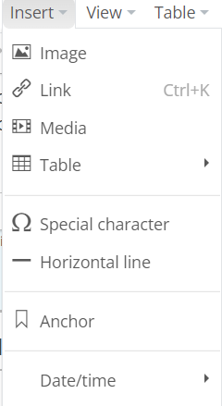

- The VIEW Prompt allows you to insert a Source Code, show blocks of text.
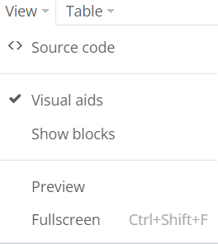

- The TABLE Prompt allows you to insert a Table and format and manipulate that table within the parameters of the text box. See the tutorial on How to Insert a Table into your Text Box.
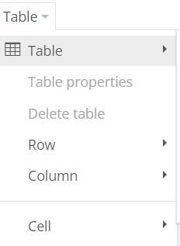

What is the Formatting Bar?

- The Formatting Bar is horizontally placed above the text box so that you can format your text within the text box.

- The arrow pointing to the left allows you to delete or go back on any content you typed.
- The arrow pointing to the right allows you to move forward.
- The B stands for Bold and can be clicked when you highlight text to stand out. The entire section of text you want bolded needs to be highlighted. Use the Bold text for headers or links or information you want emphasized. Do not bold the entire text or it will seem as if you are “shouting” at your web subscriber.
- The I stands for Italics and can be clicked when you highlight text that you want to look different from the rest.
- The Closed Paper Clip appearing link is to insert a URL from a document or a website. It shows a subscriber to click on the underlined link and go to another page or another website,
- The Open Paper Clip is used when you want to delete a link from a text box.
- The IX is used for deleting your formatting. For example if you copied text that was All Caps and you wanted to change the formatting to be Upper/Lower Case, you would highlight the text you want to change and click on Ix.
- FORMATS: These are additional text formatting.
  - Headers are the different style of headers and size that you want to use as subject headers. Best practice is to use the same style header for all pages.
  - Inline allows you to underline, to change the color of you text, the style of your text
  - Blocks allow you to control the layout of your text. If you have text that you cut and paste into the text box that is double spaced and you want it single spaced, you would highlight the text, go to Blocks and click on Pre and then Click on Paragraph and then delete the extra spacing so that your text is single-spaced.
  - Buttons allows you to create a button for a link. If you have the word Report that you want to add a link, you will type in the word Report, go to the Add Link prompt and insert a URL link for the word Report. Then you would highlight the word REPORT, go to the Buttons Prompt, and choose the style and color for Button, save your changes and update your site.
  - Images allows you to float an image to the left or right inside the text box
- The Horizontal Line allows you to insert a horizontal line within your text box.
- The Media Icon Prompt allows you to insert a link to a JPG file
- The 3 Horizontal Buttons allow you to Indent text as if it were in an outline

